1. MapReduce :

import java.io.*;

import org.apache.hadoop.io.Text;

import org.apache.hadoop.io.LongWritable;

import org.apache.hadoop.io.DoubleWritable;

import org.apache.hadoop.mapreduce.Job;

import org.apache.hadoop.mapreduce.Mapper;

import org.apache.hadoop.mapreduce.Reducer;

import org.apache.hadoop.conf.*;

import org.apache.hadoop.fs.*;

import org.apache.hadoop.mapreduce.lib.input.*;

import org.apache.hadoop.mapreduce.lib.output.*;

public class AllTimeHigh {

public static class MapClass extends Mapper<LongWritable,Text,Text,DoubleWritable>

{

private Text stock_id = new Text();

private DoubleWritable High = new DoubleWritable();

public void map(LongWritable key, Text value, Context context)

{

try{

String[] str = value.toString().split(",");

double high = Double.parseDouble(str[4]);

stock_id.set(str[1]);

High.set(high);

//context.write(new Text(str[1]),new LongWritable(vol));

context.write(stock_id, High);

}

catch(Exception e)

{

System.out.println(e.getMessage());

}

}

}

public static class ReduceClass extends Reducer<Text,DoubleWritable,Text,DoubleWritable>

{

private DoubleWritable result = new DoubleWritable();

public void reduce(Text key, Iterable<DoubleWritable> values,Context context) throws IOException, InterruptedException {

double maxValue=0;

double temp_val=0;

for (DoubleWritable value : values) {

temp_val = value.get();

if (temp_val > maxValue) {

maxValue = temp_val;

}

}

result.set(maxValue);

context.write(key, result);

//context.write(key, new LongWritable(sum));

}

}

public static void main(String[] args) throws Exception {

Configuration conf = new Configuration();

//conf.set("name", "value")

//conf.set("mapreduce.input.fileinputformat.split.minsize", "134217728");

Job job = Job.getInstance(conf, "Highest Price for each stock");

job.setJarByClass(AllTimeHigh.class);

job.setMapperClass(MapClass.class);

//job.setCombinerClass(ReduceClass.class);

job.setReducerClass(ReduceClass.class);

job.setNumReduceTasks(1);

job.setOutputKeyClass(Text.class);

job.setOutputValueClass(DoubleWritable.class);

FileInputFormat.addInputPath(job, new Path(args[0]));

FileOutputFormat.setOutputPath(job, new Path(args[1]));

System.exit(job.waitForCompletion(true) ? 0 : 1);

}

}

Hadoop command :-

hadoop jar myjar.jar AllTimeHigh /user/bigdatamind43828/cdac/NYSE.csv data1

1. Hive : -

create table custs1(

cust_id bigint,

firstname string,

lastname string,

age int,

job string

)

row format delimited

fields terminated by ","

stored as textfile;

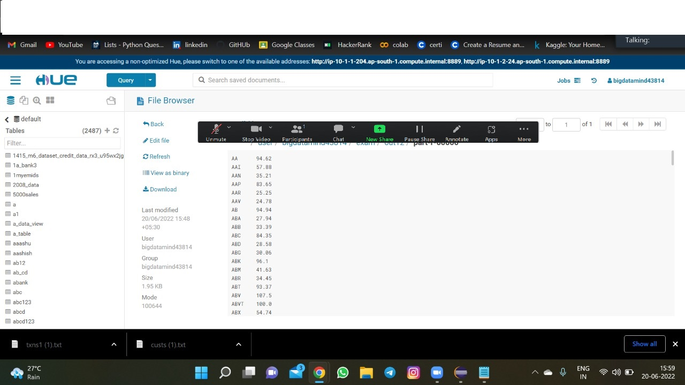

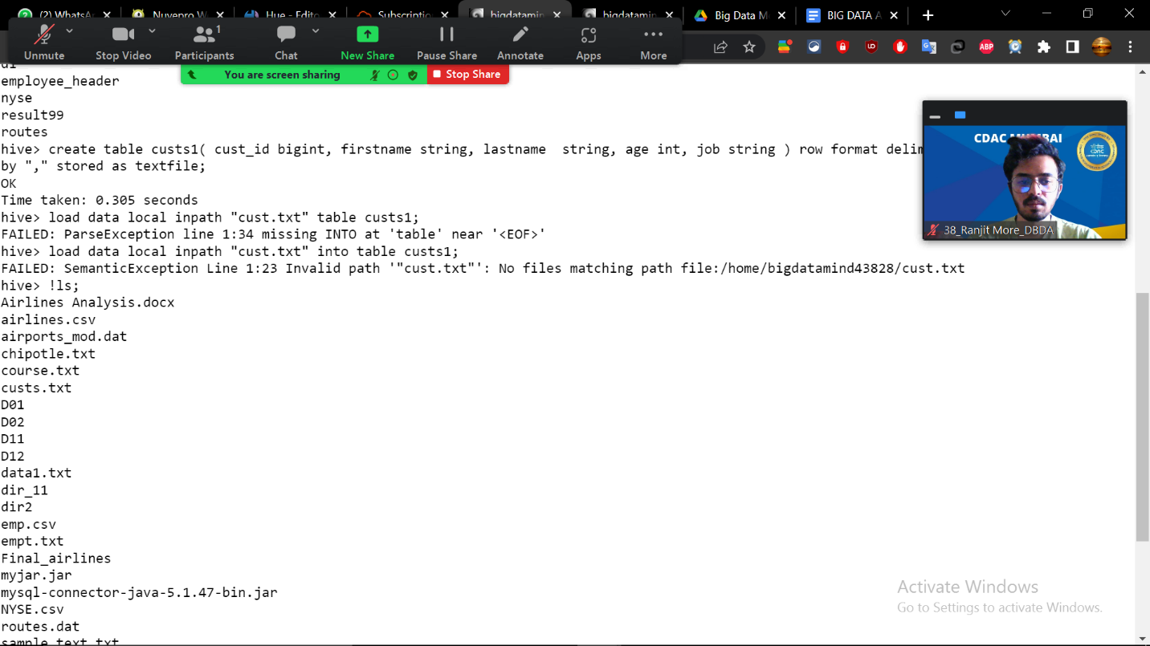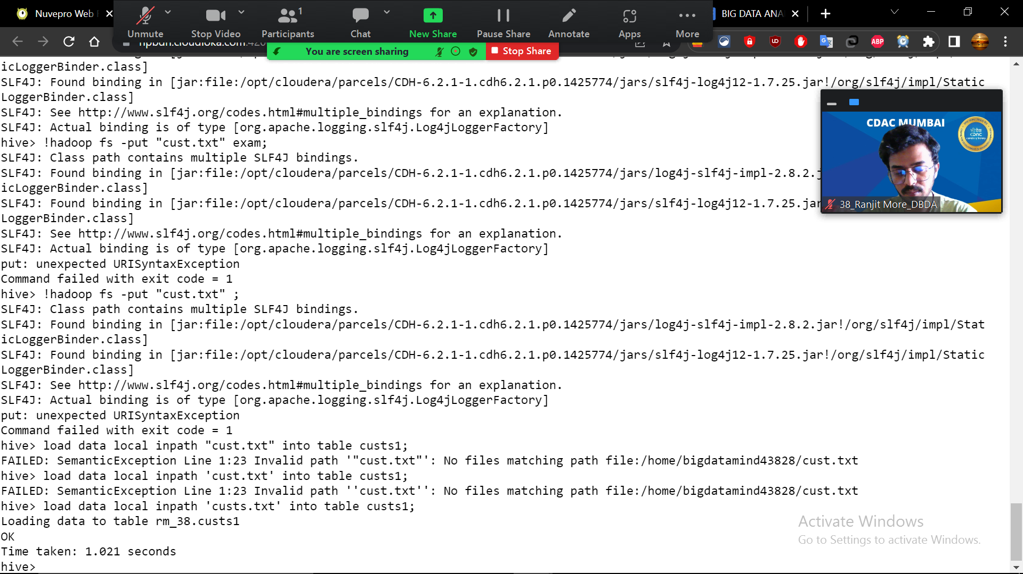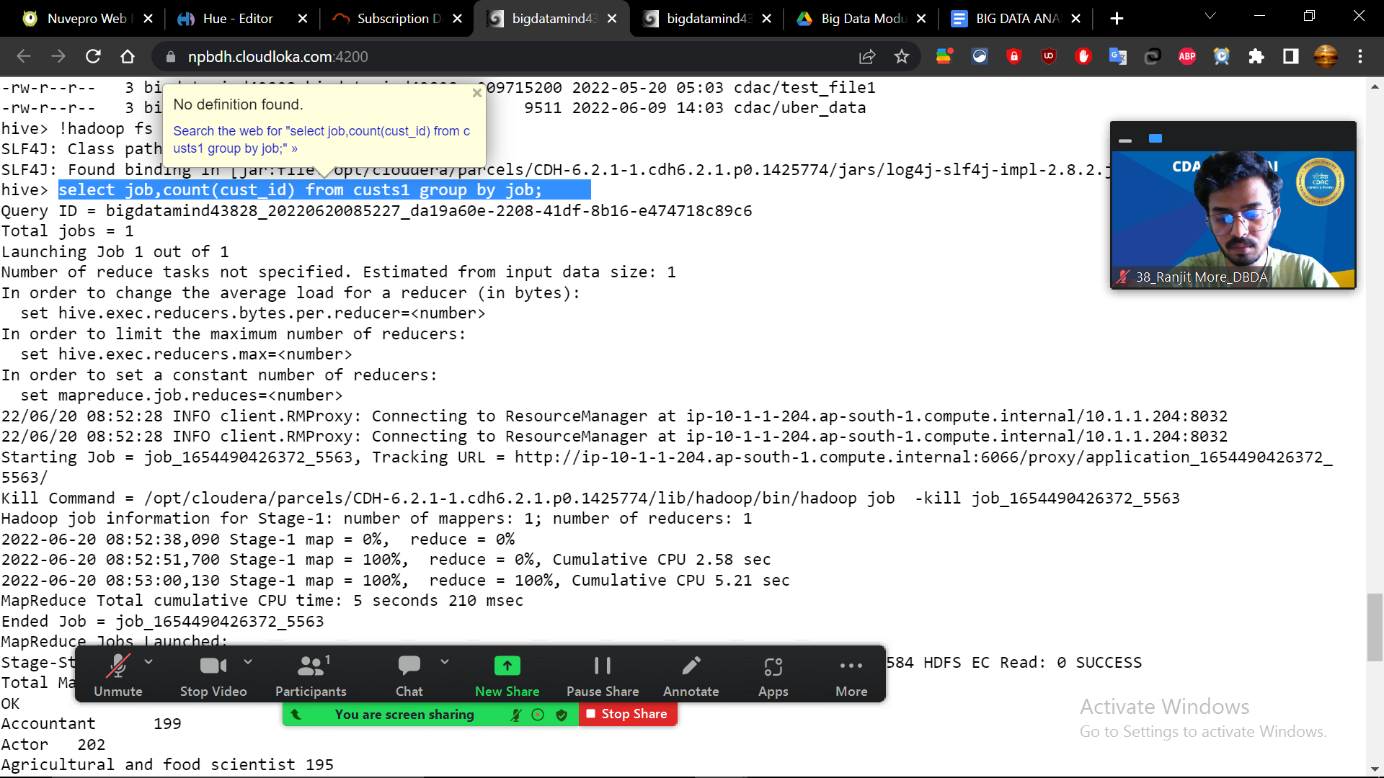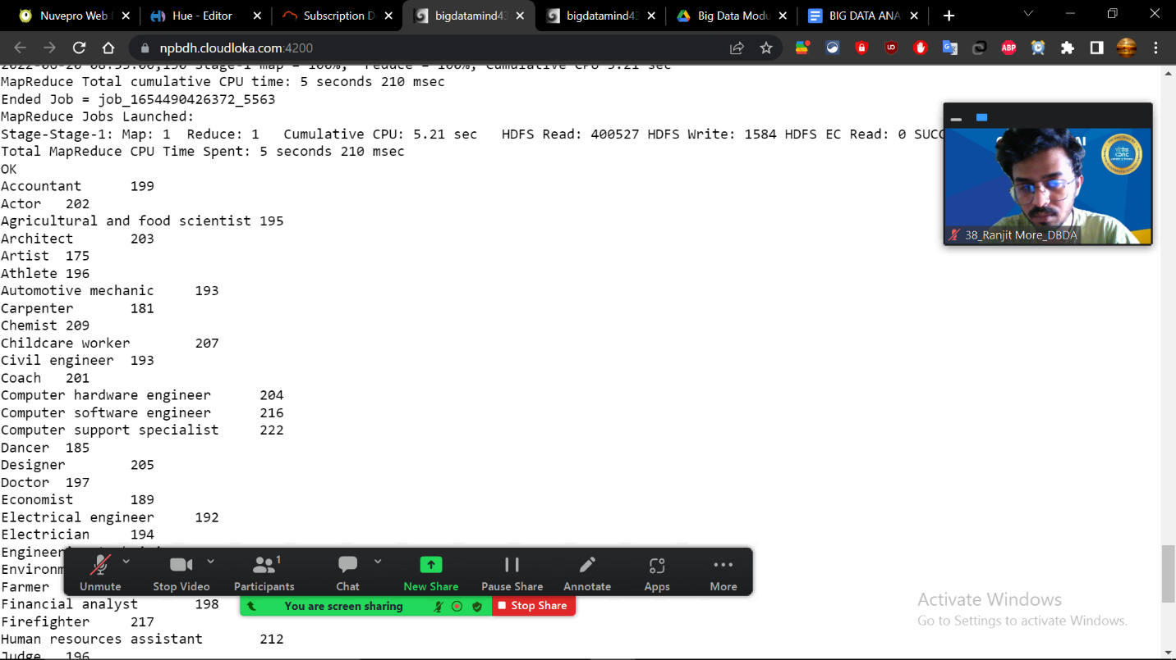

create table txn99(

txn_id bigint,

txn_date string,

cust_id bigint,

amount float,

category string,

product string,

city string,

state string,

spendby string)

row format delimited

fields terminated by ","

stored as textfile;

create table txn99_part(

txn_id bigint,

txn_date string,

cust_id bigint,

amount float,

product string,

city string,

state string,

spendby string)

partitioned by (category string)

row format delimited

fields terminated by ","

stored as textfile;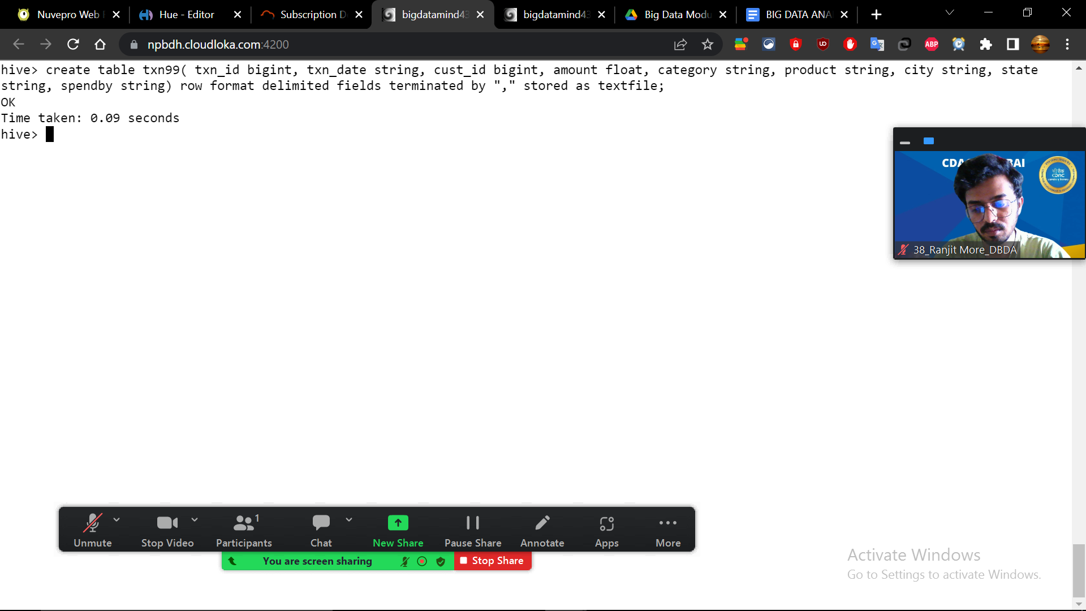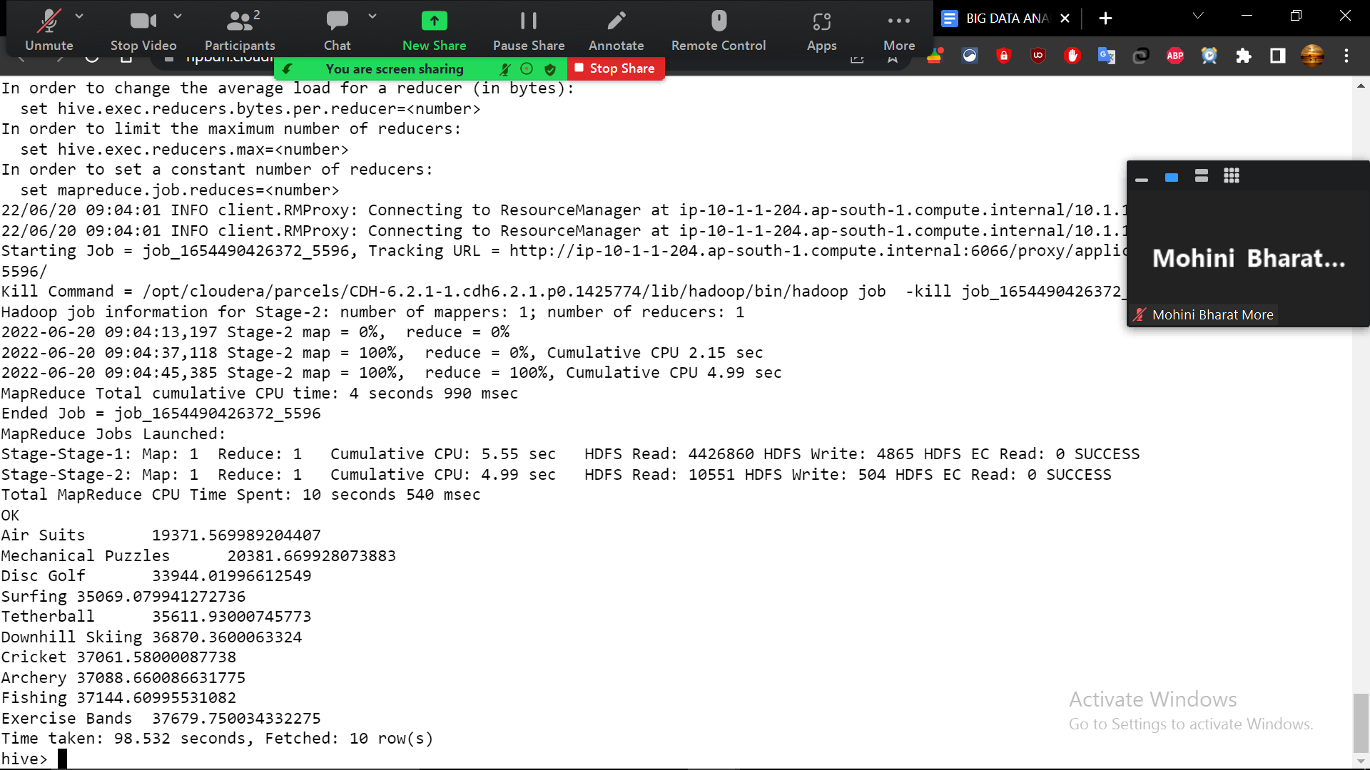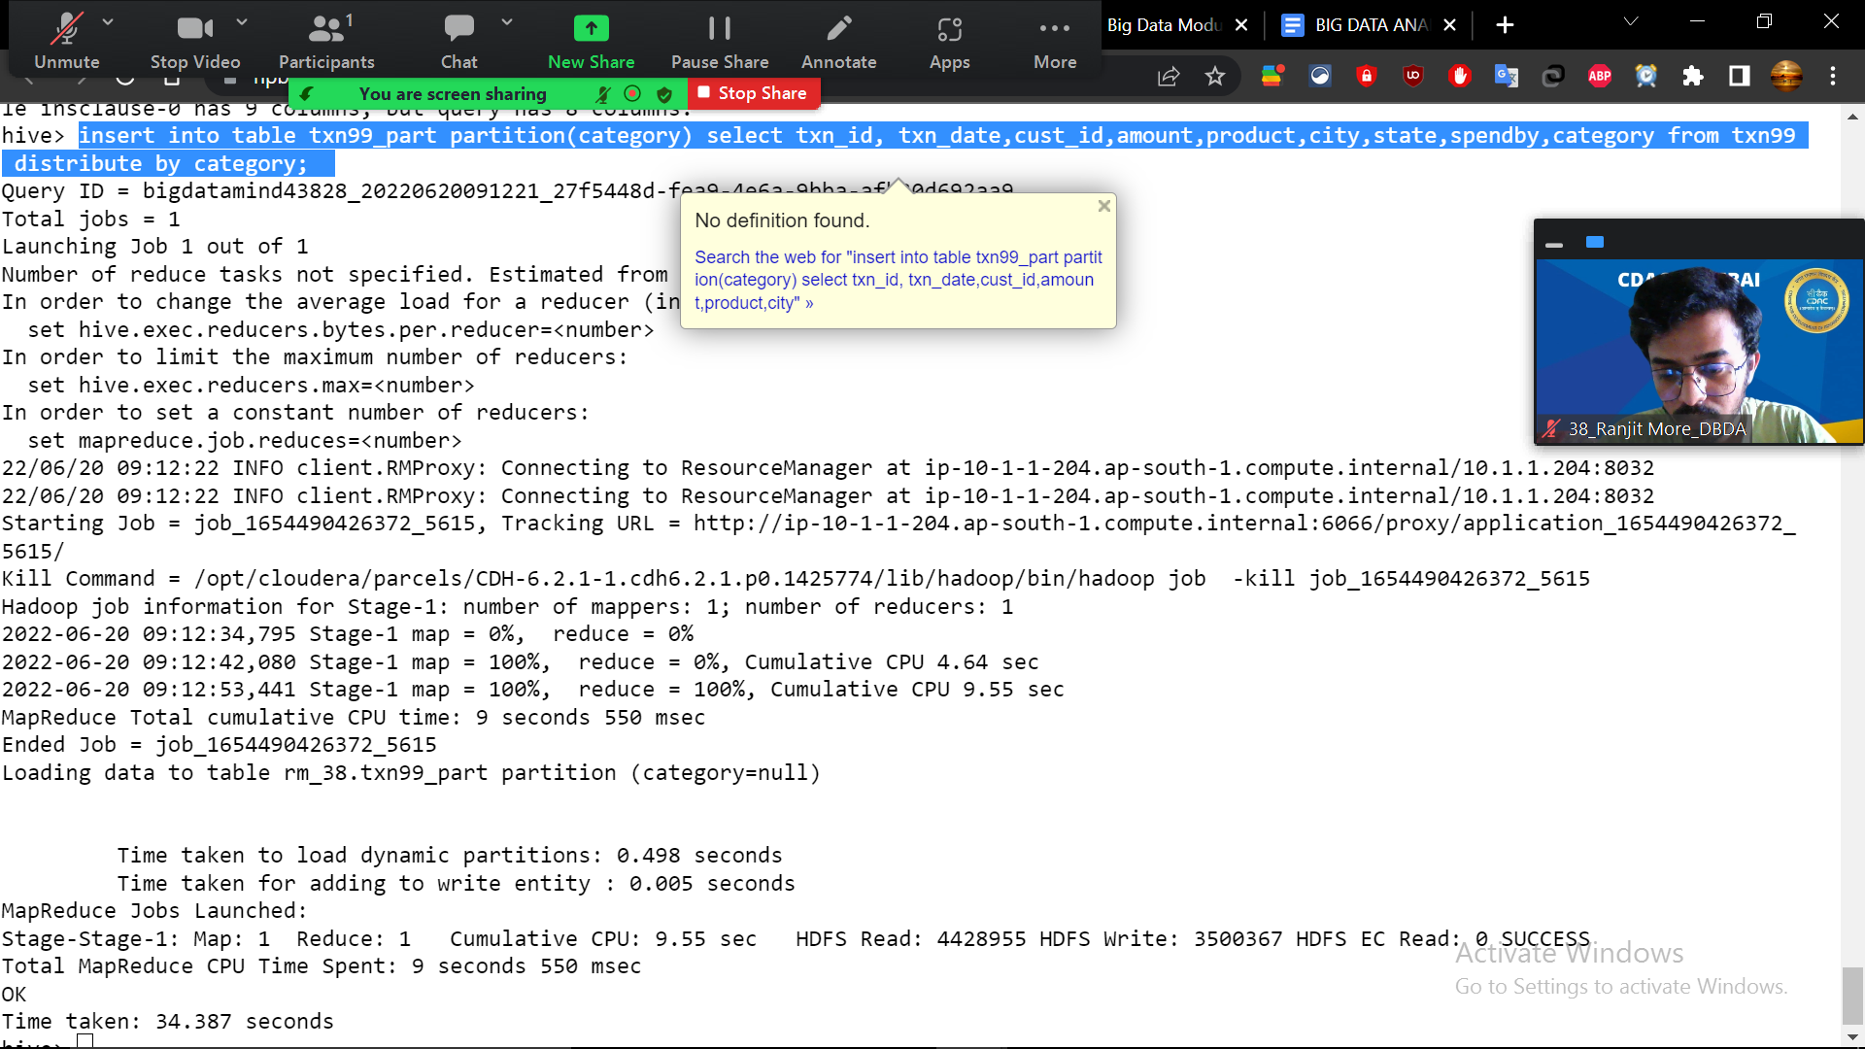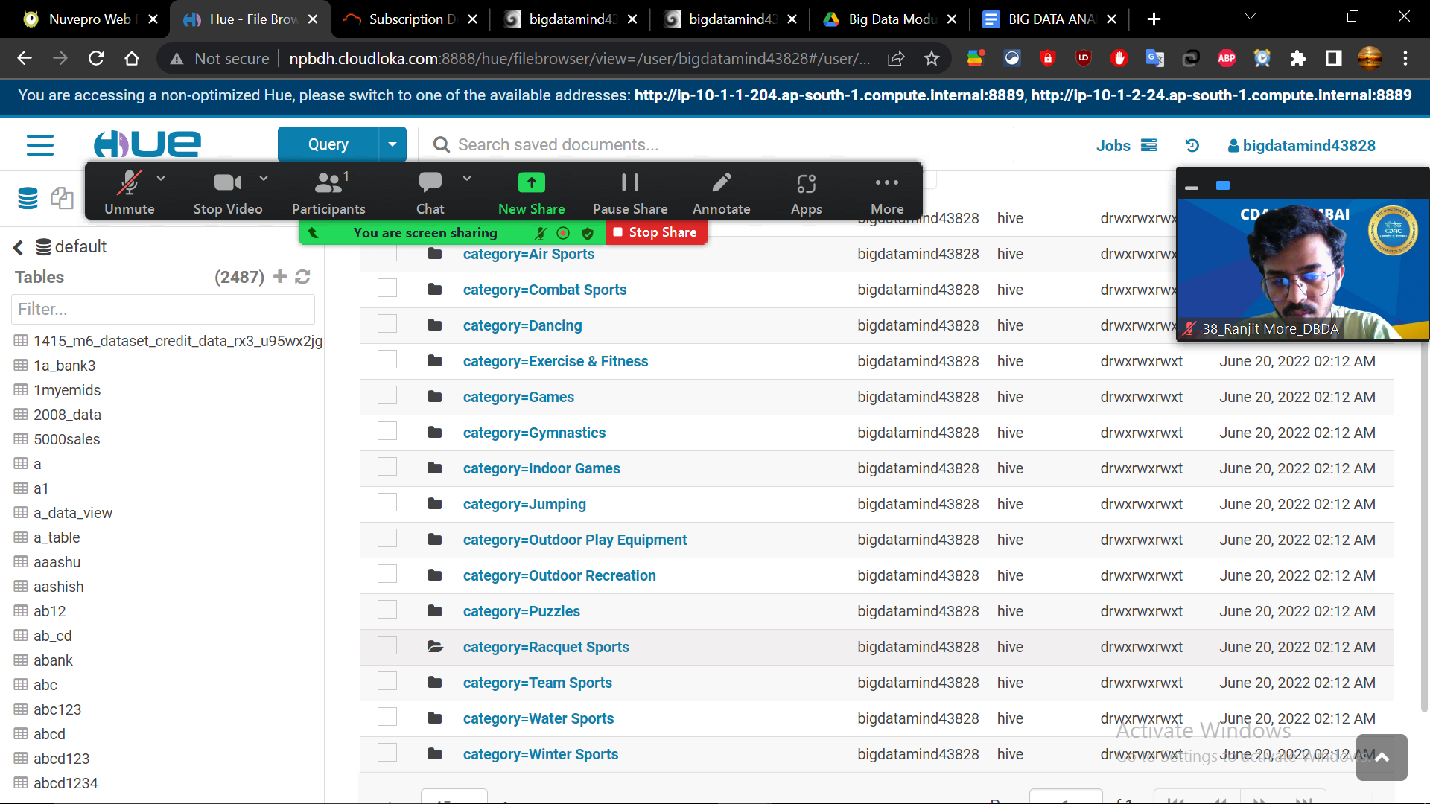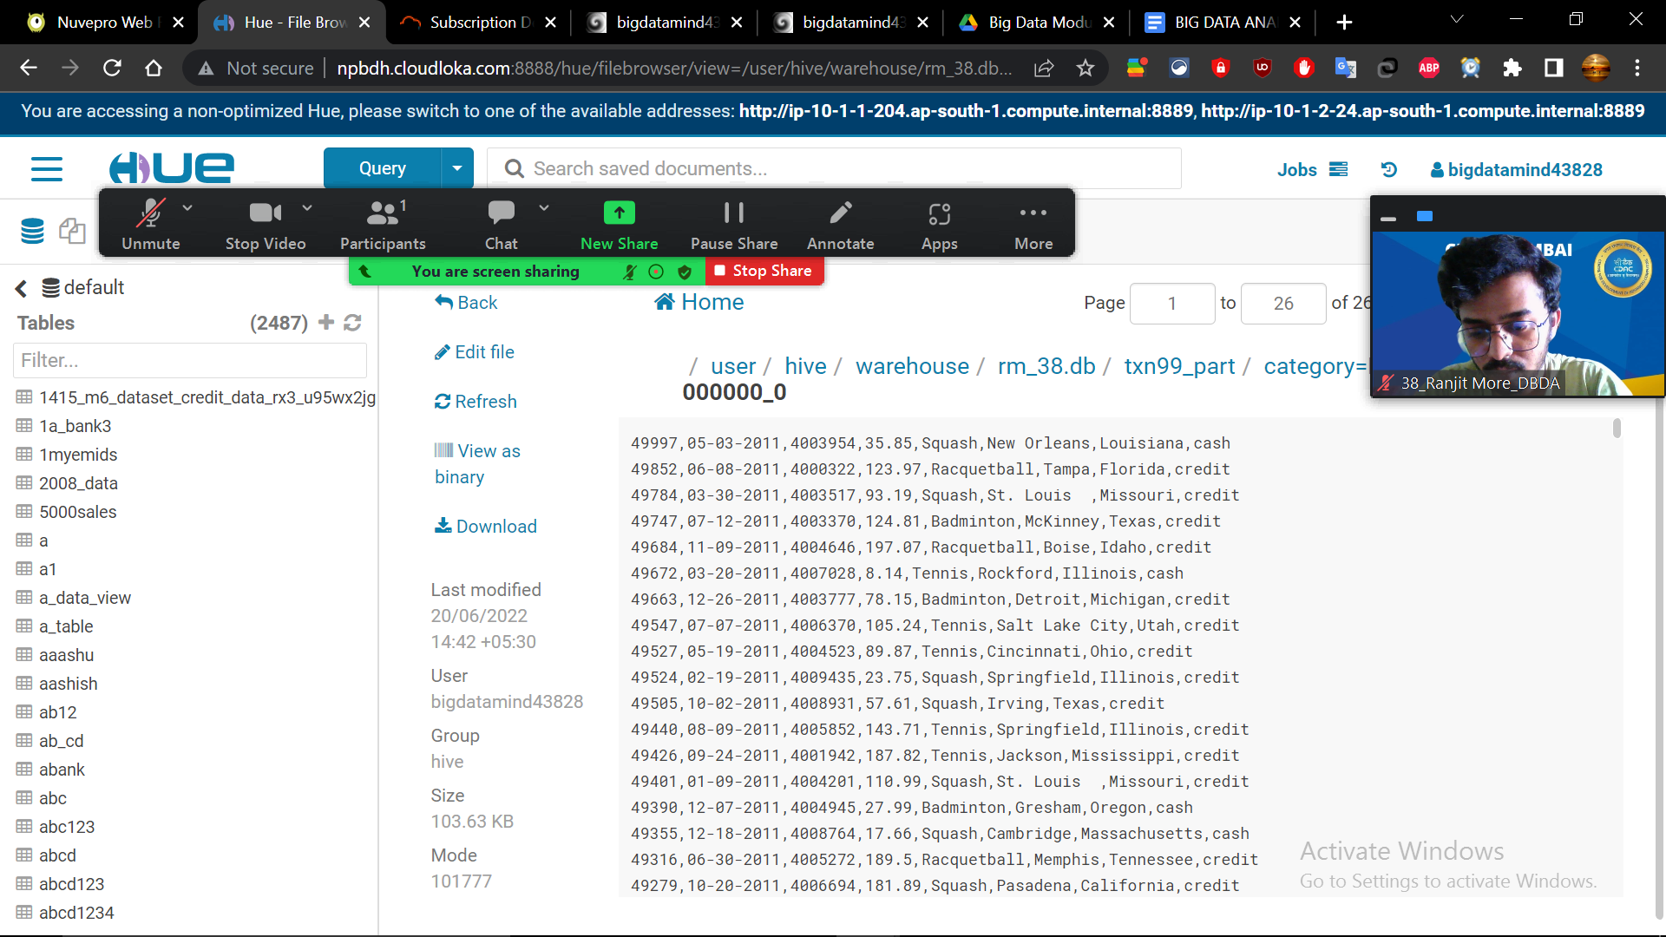

1. PySpark :-

